

**OBJECT ORIENTED PROGRAMMING**

**CSL-210**

**Project Report**

**“LIBRARY MANAGEMENT SYSTEM”**

**Class: BS(CS)-2B**

**Course Teacher: Miss Sameena Javed**

**Lab Teacher: Miss Salas Akbar**

**Group Members:**

EMAD TARIQ (02-134221-068)

AMMARAH ALI (02-134212-077)

SOHA ATHER (02-134212-088)

**Table of Contents**

01. Introduction to system 3

02. Database Explanation 4

03. Flowchart and UML 5-6

04. Screenshot of forms 7-11

05. Code Snippets 12

06. Conclusion 16

1. **INTRODUCTION TO SYSTEM:**

Library Management System is an application which refers to library systems which are generally small or medium in size. It is used by librarian to manage the library using a computerized system where he/she can record various transactions like issue of books, return of books, addition of new books, addition of new students etc.Books and student maintenance modules are also included in this system which would keep track of the students using the library and also a detailed description about the books a library contains. With this computerized system there will be no loss of book record or member record which generally happens when a non computerized system is used.

Library Management provides the following services:

**Login form** : Login form for librarian and user.

**Signup form**: Signup form to create an account .

**Librarian Dashboard:**

**ADD BOOK:** If any new book arrives in the library the librarian can enter the book details so it can be updated in the book record.

**View BOOK:** Librarian can view all the available books in the library

**VIEW USER:** All user that are registered in the system can be seen by the librarian .

**ISSUE BOOK:** User from user portal will request a book that he wants to borrow Librarian will check the availability and issue the book to the user.

**VERIFY RETURN BOOK:** User from user portal will return a book that he has borrowed Librarian will verify that he has returned the book approve request of return.

**USER DASHBOARD:**

**VIEW USER:** User can view its personal detail from the dashboard.

**REQUEST BOOK:** User wants to borrow a book will have to request book from the librarian later the availability will be checked by the librarian and will be issued by him

**RETURN BOOK:** User wants to return a book will have to send a return request book from the librarian later the verification will be done by the librarian and will approve its return request

1. **DATABASE EXPLANATION:**

The class DBConnection consists of methods for connection of db, user,librarian login, and adding the records in access database.The class DB connection consists of objects from our backend classes which will be used in the following methods.

The method Estconnection() consists of complete path for access files. After giving the path of UcanAccess we have concatenated the location of our Access files.

In the methods user and librarian login we pass a query to select all data from the tables in access database. The method type is Boolean which returns true if the login data matches the data in the access database and allow the following users to work on their respective pages.The methods returns the information , fetching from the database if the condition is true.

The method adduser() Signs up a user and the query for inserting the data is passed to the database(user details).

The method addbook() passes a query for inserting book the details from the Jframe is passed on to the function which is passed and stored in database.

The method approveRequest() and returnBook() passes the query to display return book request coming from the user which will be later verified by librarian .

3. **FLOWCHART AND UML DDDDDDDDIADUML ::DIAGRAM:**

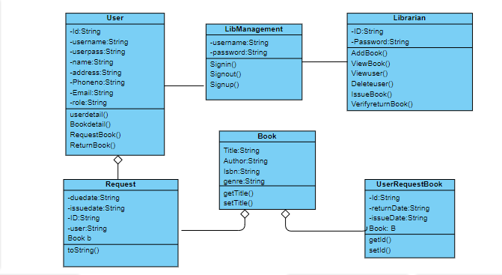

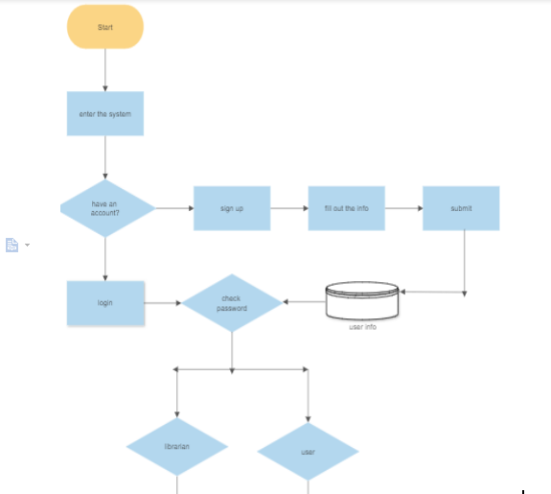

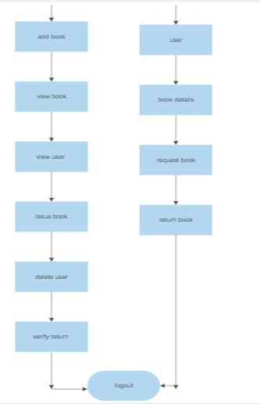

1. **SCREENSHOT OF ALL FORMS:**

**OPENNING SCREEN:**

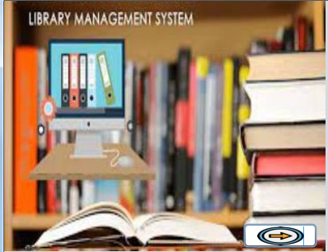

**LOGIN FORM: Login form for user and librarian**

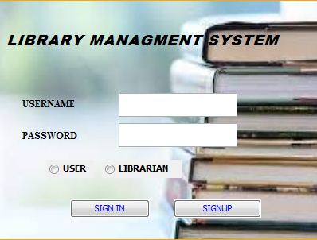

**SIGNUP FORM: Signup form for players.**

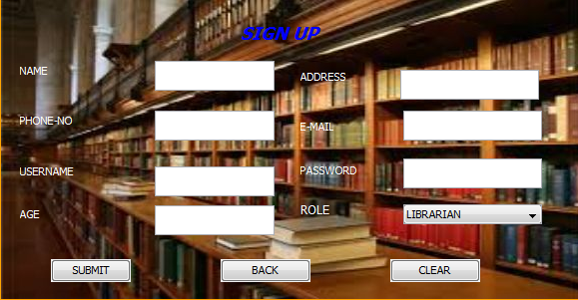

**USER DASHBOARD:**

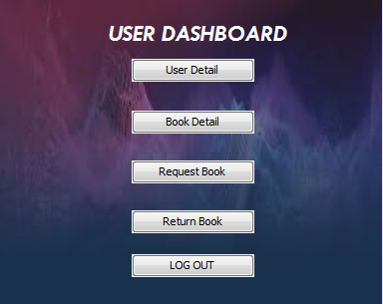

**USER INFORMATION DISPLAY:**

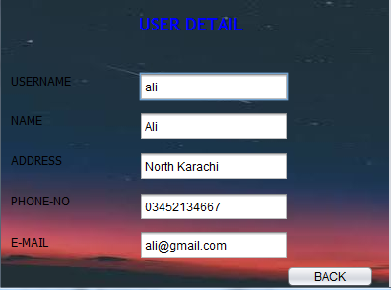

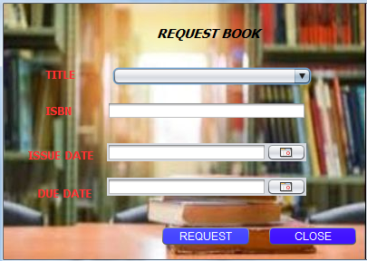**USER REQUEST BOOK:**

**RETURN BOOK:**

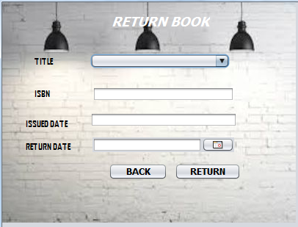**LIBRARIAN DASHBOARD:** 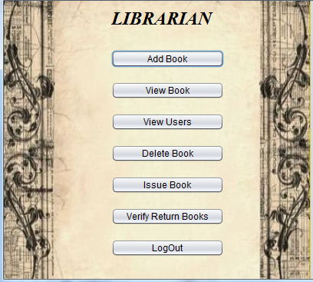

**ADD BOOK:**

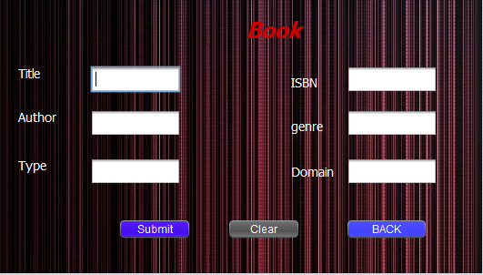

**VIEW AVAILABLE BOOK:**

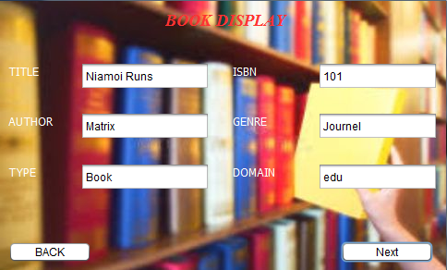.

**DSIPLAY ALL USER TO LIBRARIAN:**

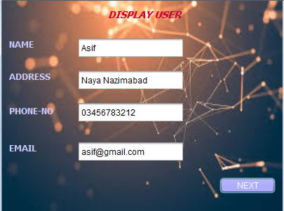

**DELETE BOOK:**

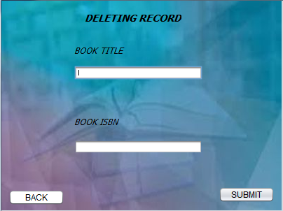

**ISSUE BOOK:**

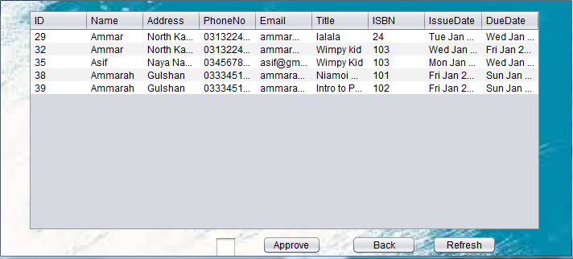

**VERIFY RETURN BOOK:**

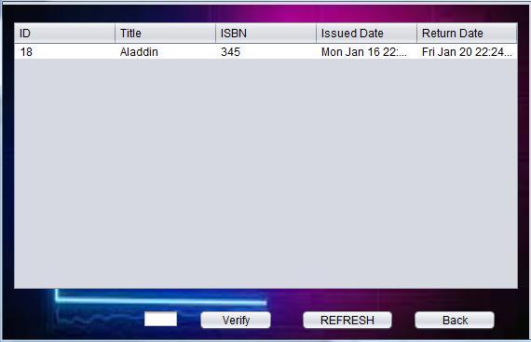

1. **CODE SNIPPETS:**

***BOOK CLASS***

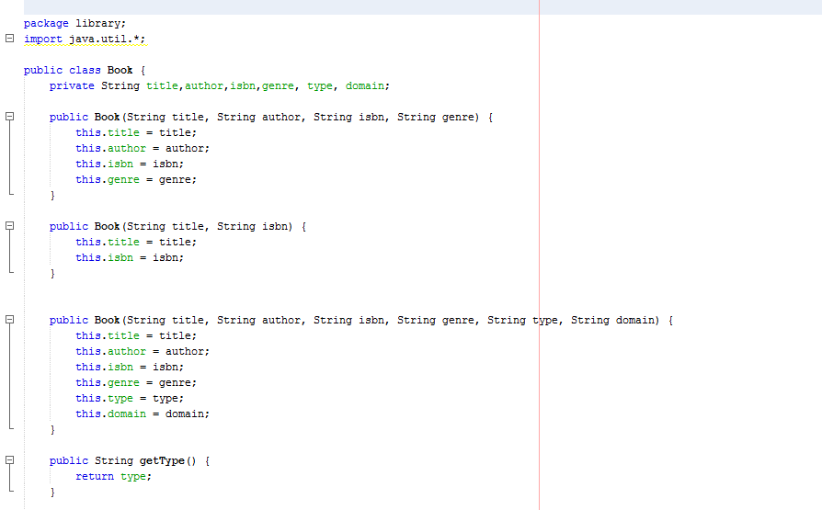

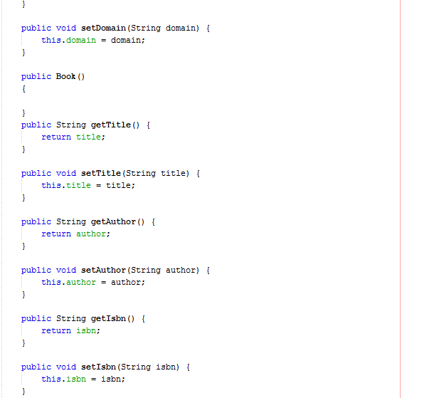

*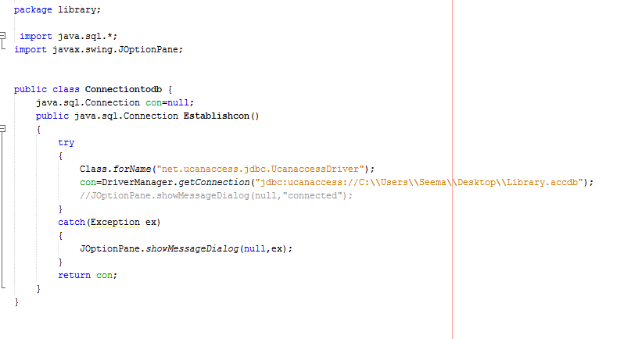****CONNECTION:***

***REQUEST CLASS:***

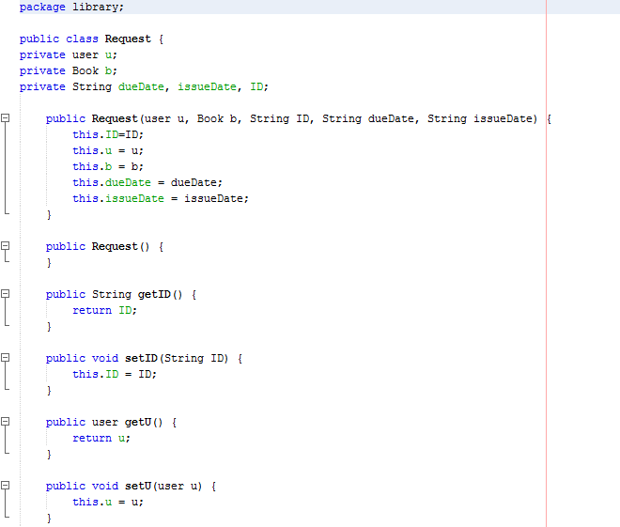

***USERRETURNBOOK:***

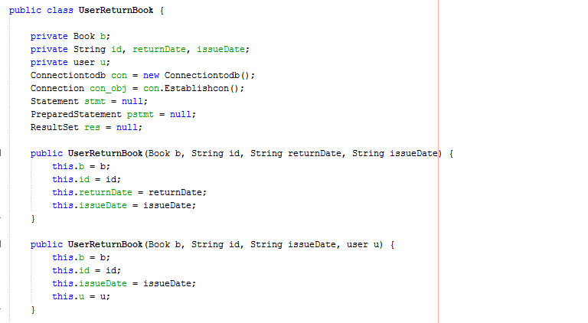

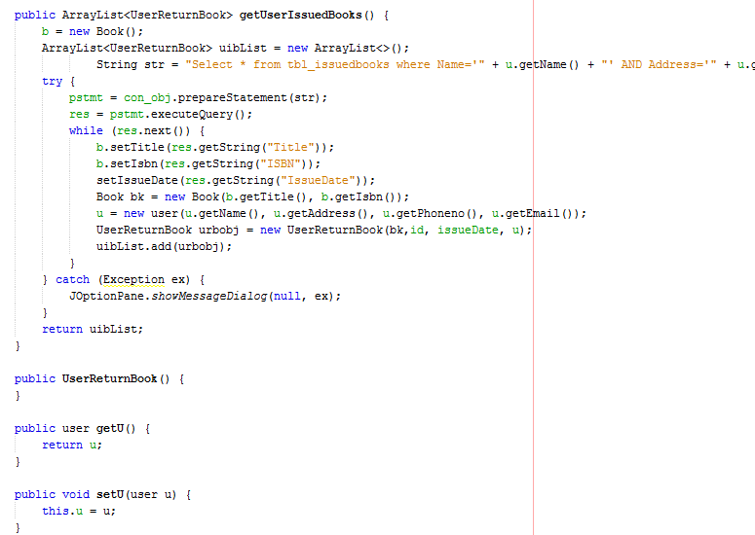

***LIBRARIAN:***

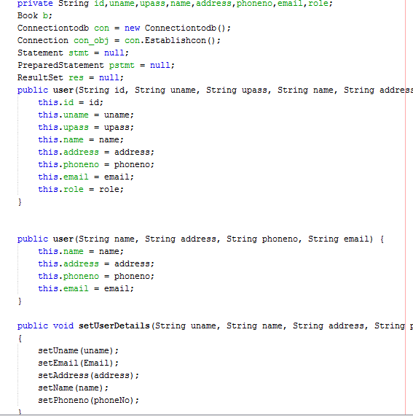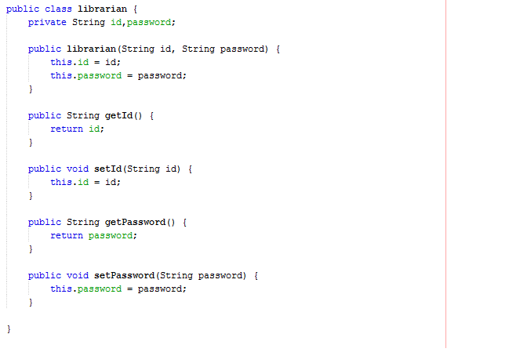***USER CLASS:***

***BOOKFN:*** this class consist of all librarian function and user function:

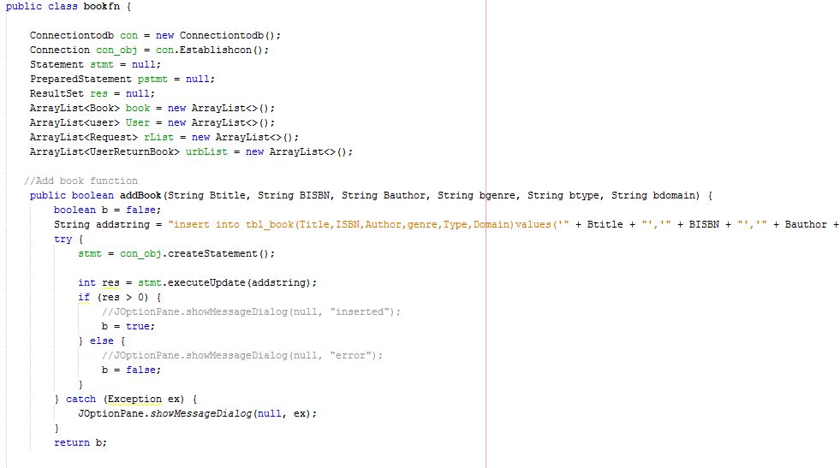

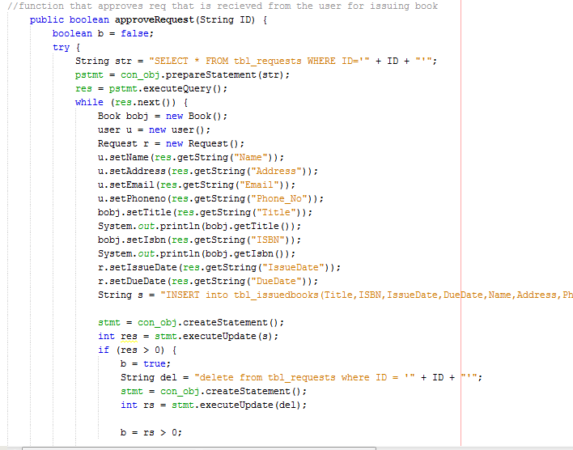

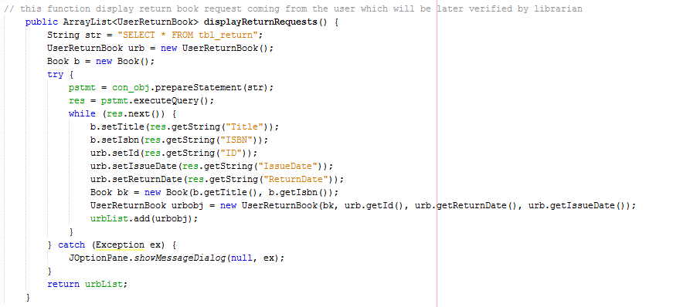

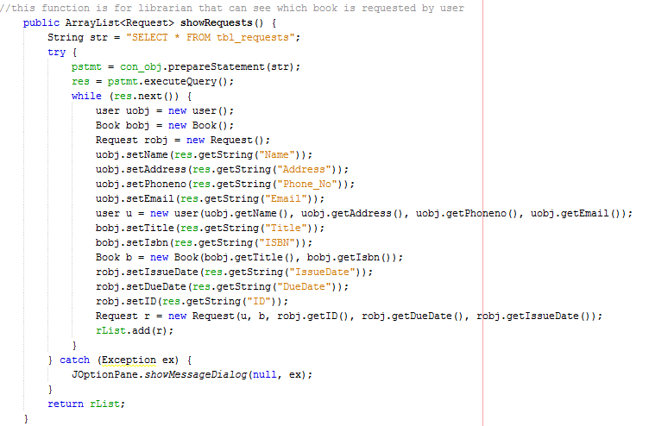

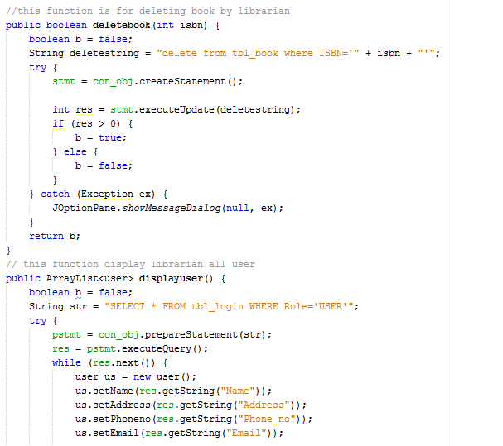

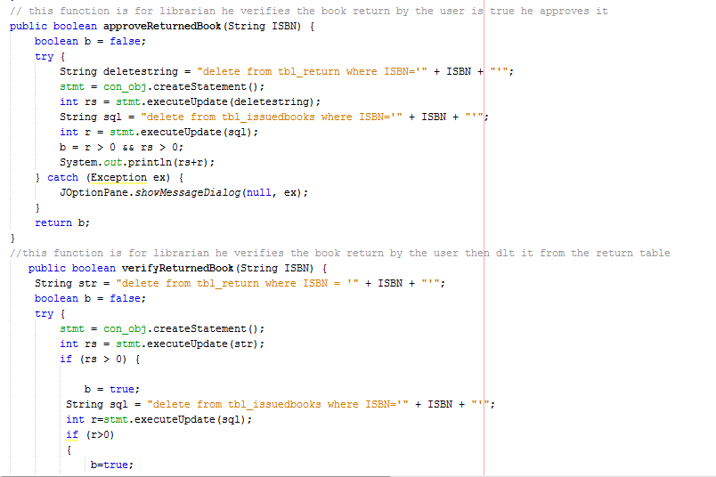

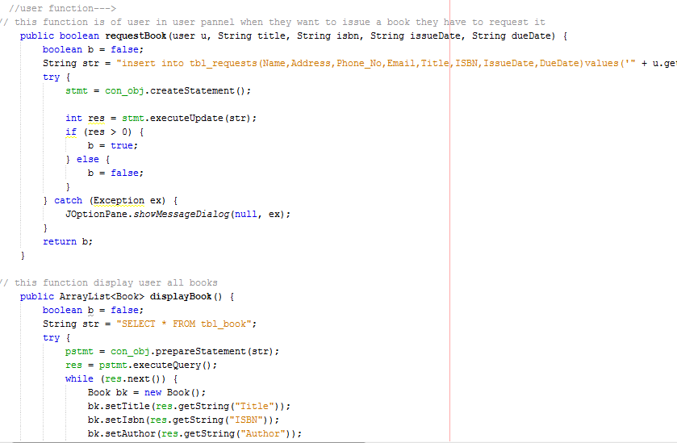

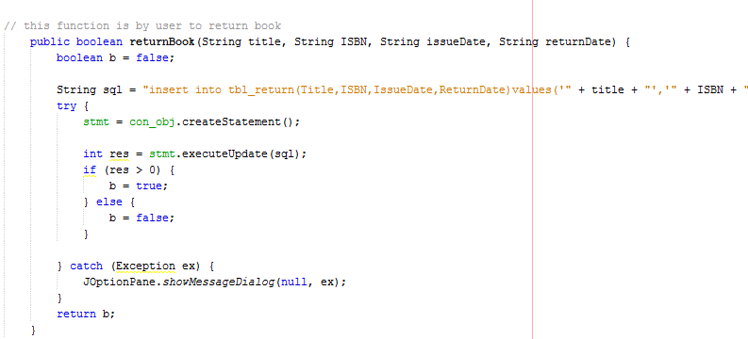

***LOGIN USER:***

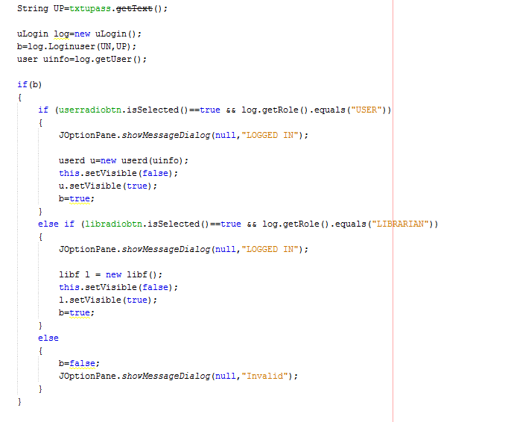

***User LOGIN CLASS:***

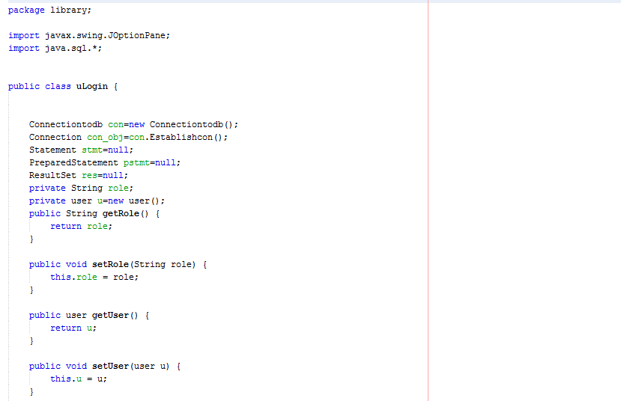

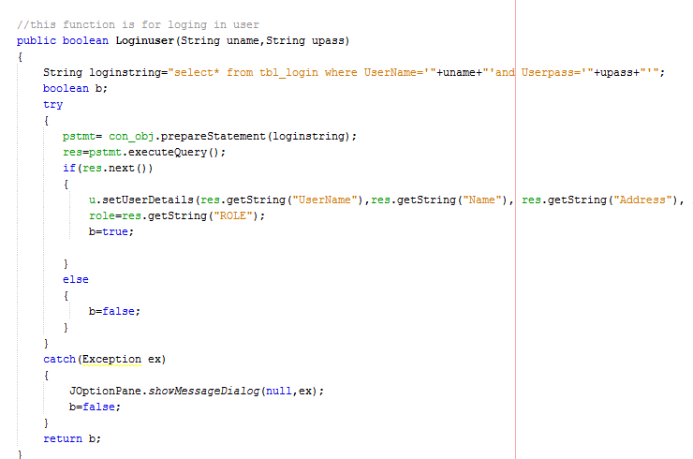

SIGNUP:

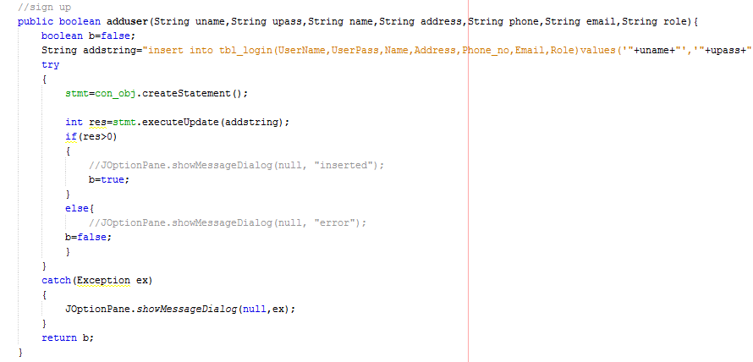

UPDATING USER:

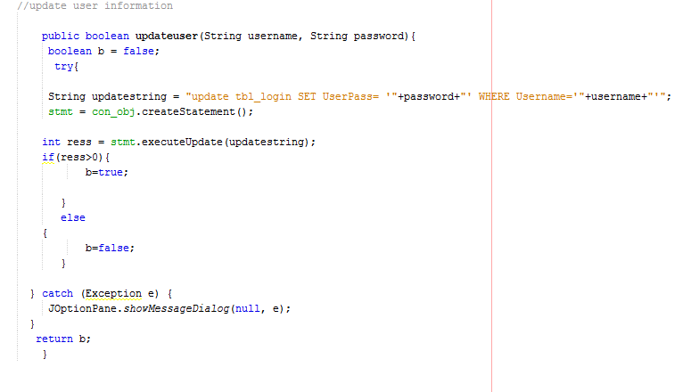

1. **CONCLUSION**

* In Conclusion Library is a user friendly program where users can easily find borrow return book
* It can facilate Librarian to keep record of the books.
* User can easily find Books of their interest and can get them issued
* Librarian is full control over issuing and returning track from the user.